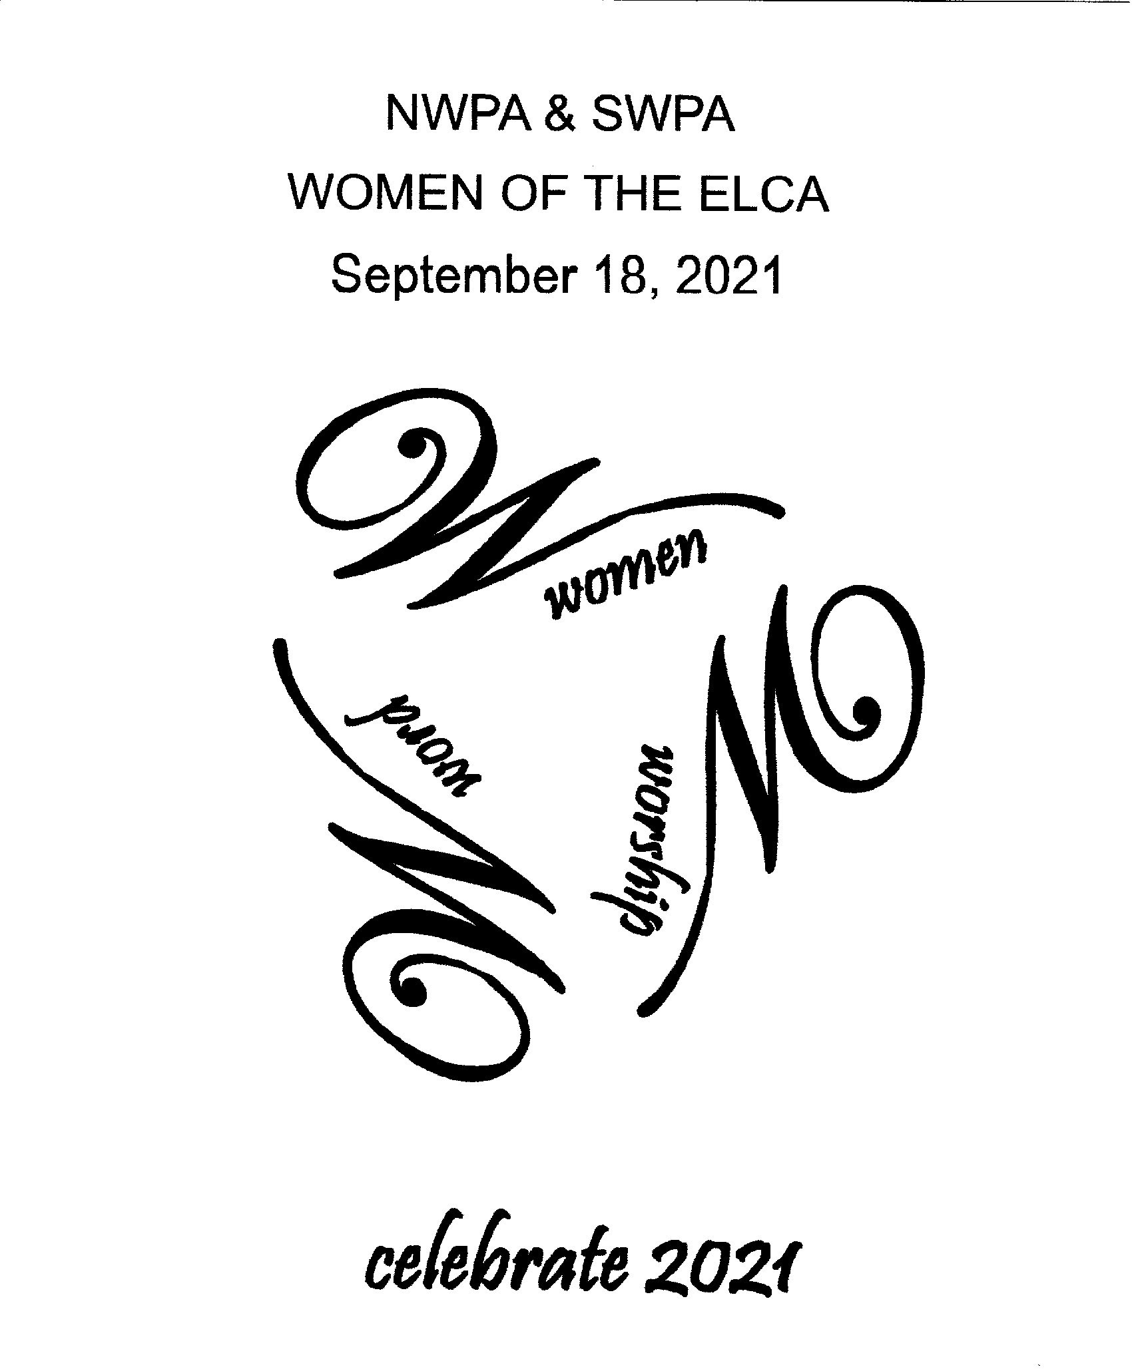

NWPA & SWPA RETREAT REGISTRATION FORM
September 18, 2021

PLEASE COMPLETE ENTIRE FORM AND PRINT LEGIBLY:

Name: ______________________________________________________________________________
Address: ______________________________________City/State/Zip: _________________________
E-mail: ______________________________________________ Phone #: _______________________
Home Congregation: ________________________________ City: ___________________________

CIRCLE ONE: Northwest Synod OR Southwest Synod First time participant? Yes OR No

Emergency Contact: _______________________________ Phone #: ________________________

Special Needs: ________________________Dietary Restrictions: ____________________________

SATURDAY RETREAT FEE - Registration forms due no later than August 27th

REGISTRATION:

Registration fee - $67.00 for the day
This includes a registration fee, continental breakfast, lunch and dinner.

Registration Fee Due: $67 .00

Registration forms WILL NOT be accepted after August 27th (No Exceptions)

PLEASE MAKE CHECKS PAYABLE TO SWPA-SWO-W/ELCA
++++++++++++++++++++++++++++++++++++++++++++++++++++++++++++
Please mail this registration form and the events form along with your check to:

Jeannie North Cell phone #: (412)860-9737
210 Elrose Drive bettsnor@hotmail.com
Pittsburgh, PA 15237
Information for Registrar to Complete:

Date Form Received: ___________________________
Registration Amount Paid: $______________ Check # _____________

Workshops Requested: #1______________________________________
#2______________________________________

Will participate in Cornhole Tournament Yes_____ No_____
Saturday Retreat Events (9/18/21)

Please select your choice for each time slot and return this sheet with your registration form.

12:00 – 12:30 – Me Time. Take some time to visit the Prayer Room, shop in Fair Trade, rock on the porch, find a friend or practice your cornhole skills.

1:15 – 2:00 – Celebrating Women Event – Pamper Yourself

2:15 – 3:00 Workshop

_____ Holy Hike – Sue McCabe (meet at Rice Hall)

_____ Pastors on the Porch – Pastors Kristen Papson and Beth Siefert – “Being a Woman in Ministry”

_____ Internet Safety for Adults – Michelle Flaherty (held in Chapel)

3:15 – 4:00 Workshop

_____ Holy Hike – Sue McCabe (meet at Rice Hall)

_____ Pastors on the Porch – Pastors Kristen Papson and Beth Siefert – “Being a Woman in Ministry”

_____ Internet Safety for Adults – Michelle Flaherty (held in Chapel)

4:15 – 4:45 –Outdoor Game Tournament – Corn Hole
Bingo

Participating in Corn Hole Tournament Yes______ No_______

KEEP THIS PAGE FOR YOUR RECORDS

In case of emergency/information, Lutherlyn may be reached anytime at (724)822-3715.
Weekend Retreat Chairperson, Mary Alice McMunn at (814)813-5099 or Co-Chair Janet Sesti at (412) 310-6830.

My 2:15-3:00 PM Workshop:____________________ My 3:15-4:00 PM Workshop____________________

Participating in Corn Hole Tournament Yes______ No______
======================================================================

√ CHECKLIST OF THINGS TO BRING:

●Bible, notebook & pen ●Wear comfortable shoes
●Jacket or sweater ●In-gathering items for your Synod -
●Raingear NW – Monetary donations
●Water Bottle SW – Target gift cards
●Offering ●Seat cushion (optional)

REGISTRATION TIME – At this time, a continental breakfast will be provided.

Saturday, September 18 – 8:00 am – 9:00 am in Entrance hall to Dining Room

THINGS TO REMEMBER:

- No registrations will be accepted after August 27th, 2021.

- Lutherlyn will follow the CDC and State guidelines. Medical excuses cannot be accepted. Masks must be worn at all times. Face shields are not considered a mask. Social distancing will be practiced. Hand sanitizer will be provided.

- After the registration deadline, refund requests must be made in writing to your SWO President no later than October 17, 2021.

Date Registration Mailed:________ Check #:________ Amount: $_________

WELCA 2021 Lutherlyn Retreat

Theme: Celebrating Women ~ Worship ~ Word

- Women: Celebrating 50 years of ordination for women pastors and all women of faith

- Worship: God Who Writes All People’s Story (Song)

- Word: Proverbs 4:8 – Exalt her, and she shall promote thee: she shall bring thee to honour, when thou dost embrace her

================================================

Offerings will be collected during the worship service on Saturday and dispersed as follows:

- 50% of the offerings will be sent to churchwide WELCA for each synod.

- 25% will be given to each individual SWO’s outreach project:

NWPA’s – Children Youth Services for Conference 4
SWPA’s – Blessed Bundles

- 25% of the offerings will remain in NWPA and SWPA SWO’s Treasury’s.

Please feel free to duplicate all forms and share with your friends.

